# Example Positions/Jobs

* SPP Coordinators
* SPP Directors
* NGB Joint Staff (J53)
* GCC Staff
* NGB BAOs
* DOD SPP Stakeholders

# Functional Area Description

The State Partnership Program (SPP) functional track is provided for practitioners and relevant stakeholders to understand, implement, integrate, and sustain the State Partnership Program (USC Title 10, §341) as part of U.S. Security Cooperation in alignment with and support of United States national security strategy.

# How will this prepare you better for your work?

The learner will be able to demonstrate an understanding of the National Guard management and administration of the DoD’s State Partnership Program (SPP), recognize the many interrelated aspects of the SPP with other security cooperation authorities, programs, and stakeholders. The learner will be able to demonstrate the linkage between U.S. National Security goals and objectives and their State Partnership Program activities with foreign partners. The learner will be able to plan and execute SPP activities in compliance of U.S. law and policy, nested within U.S. strategic guidance, using the authorized resources available to the program, while contributing to Assessment, Monitoring & Evaluation (AM&E) requirements.

**Practitioner Certification Program of Study**

# Core Education and Training

**Primary Functional Training**

**(Available starting FY25)**

# Secondary Functional Training

**(Available starting FY25)**

# Leadership Training

* + **CD 201** Capability Development for Practitioners
  + **TSFD 201** Technology Security Foreign Disclosure, and End-use Controlsfor Practitioners
  + **PMA 201** Political Military Activities for Practitioners
  + **REG 201** Orientation to Regional Security for Practitioners
  + **SPP 224** The State Partnership Program

**Complete one of the following per your supervisor:**

* + **PR 101** Foundational Policy and Resourcing
  + **SCO 120** Security Cooperation Organization (SCO) Basic Operations
  + **INT 1110** International Acquisition/Security Cooperation Foundation
  + **BPC 150** BPC Foundations
  + **ATE 121** Foundations of the International Military Student Office (IMSO)
  + **AME 110** Foundations of AME

Lead Teams / Projects

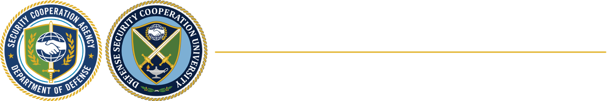

CERTIFICATION PATHWAY FACT SHEET

State Partnership Program – Practitioner

# Continuous Learning Examples (60 hours every 2 years)

For a complete list, click **HERE**.

[www.dscu.edu](http://www.dscu.edu/) [www.linkedin.com/company/dscu](http://www.linkedin.com/company/dscu)